1. **Insert water marking to the image using OpenCV.**

**Aim:**

To perform watermarking to the image using opencv.

**Code:**

import cv2

img = cv2.imread(r"C:\Users\prith\Documents\CV\cvimage.jpg")

wm = cv2.imread(r"C:\Users\prith\Documents\CV\cvimage.jpg")

h_wm, w_wm = wm.shape[:2]

h_img, w_img = img.shape[:2]

center_x = int(w_img/2)

center_y = int(h_img/2)

top_y = center_y - int(h_wm/2)

left_x = center_x - int(w_wm/2)

bottom_y = top_y + h_wm

right_x = left_x + w_wm

roi = img[top_y:bottom_y, left_x:right_x]

result = cv2.addWeighted(roi, 1, wm, 0.3, 0)

img[top_y:bottom_y, left_x:right_x] = result

cv2.imshow("Watermarked Image", img)

cv2.waitKey(0)

cv2.destroyAllWindows()

**Input:**

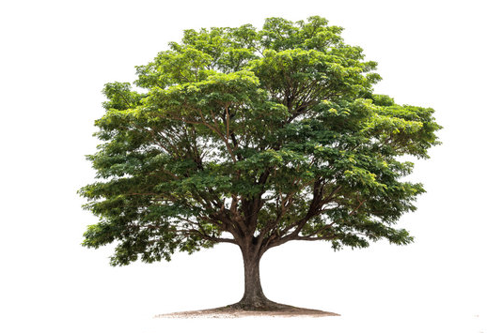

**Output:**

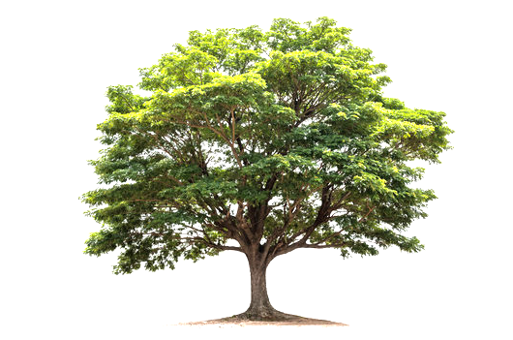

**Result:**

The python code to perform watermarking an image has been executed successfully.